This time I processed both bills at same time in EA00, final bill and interim bill
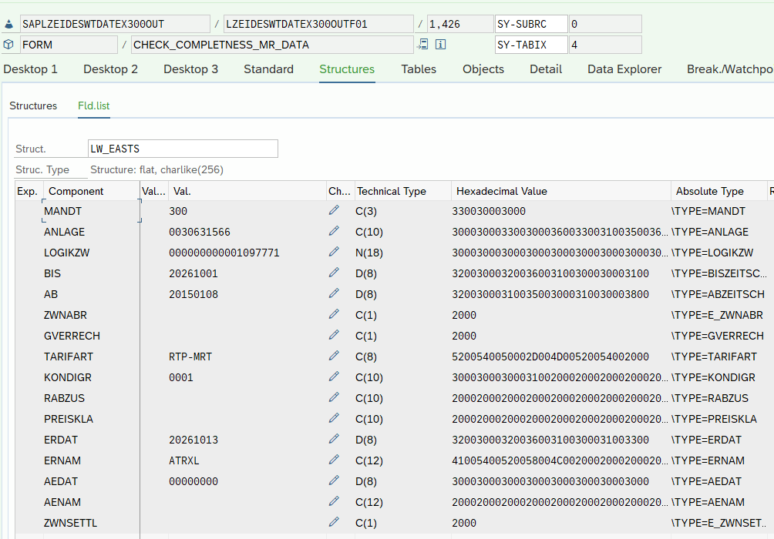
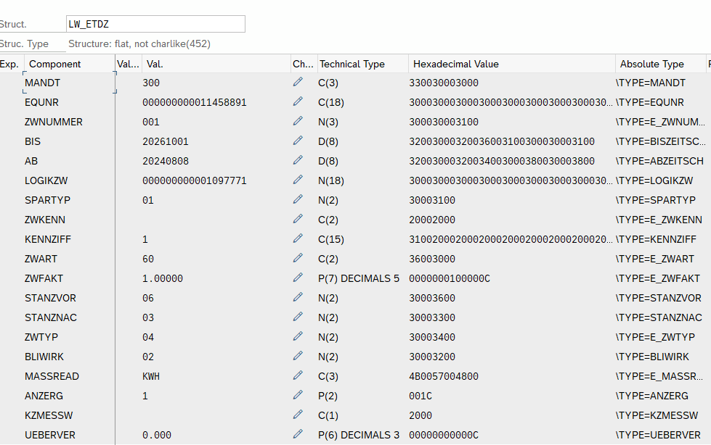

Follow up questions
- This is a physical meter change
Change in EQUNR.
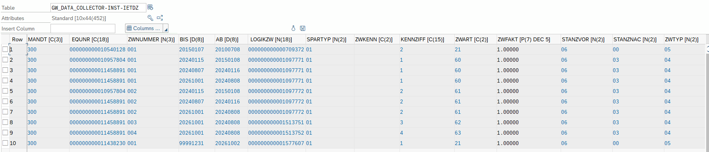
- Contract change?
Yes contract change is intentional.
P_PREV_BELNR = 020630176501

3)
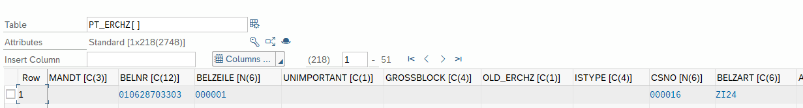
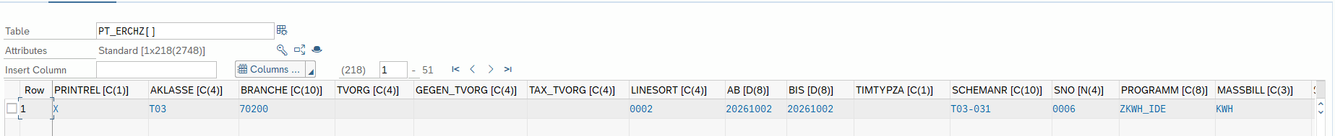
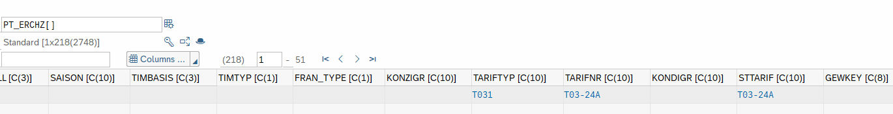

LV_FOUND, is not set at either checkpoint
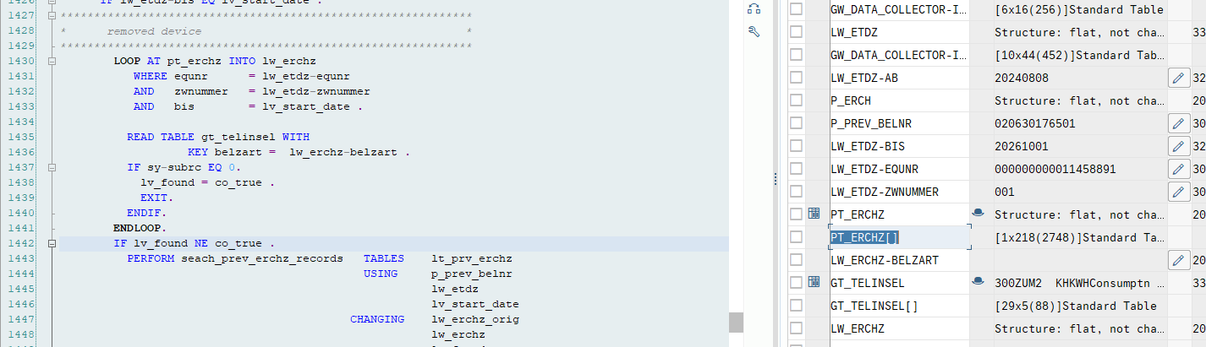
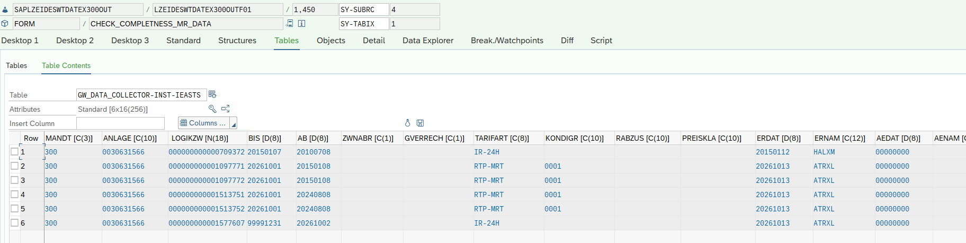
4)
FORM seach_prev_erchz_records TABLES pt_prv_erchz STRUCTURE erchz
USING p_prev_belnr
p_etdz TYPE etdz
p_keydate
CHANGING p_erchz_orig TYPE erchz
p_erchz TYPE erchz
p_found .
************************************************************************
* Form will add to the billing line times of the current billing *
* the billing line items of the previous period bill *
* *
* Result: the full Meter works event that covers day X and day X + 1 *
* is accessible for further processing *
************************************************************************
* Get previous billdoc
DATA: wa_eablg TYPE eablg,
wa_eabl TYPE eabl.
*******************************************************************
* READ BILLING LINE ITEMS *
*******************************************************************
IF pt_prv_erchz[] IS INITIAL .
CALL FUNCTION 'ISU_DB_ERCHZ_SELECT_BILL'
EXPORTING
x_belnr = p_prev_belnr
TABLES
t_erchz = pt_prv_erchz
EXCEPTIONS
not_found = 1
not_qualified = 2
not_valid = 3
OTHERS = 4.
IF sy-subrc > 1.
* System Error
mac_msg_repeat co_msg_error general_fault.
ELSEIF sy-subrc = 1 .
* Valid scenario - billing document w/o billing line items!
ENDIF.
* Now add the line items of the previous bill/final and change
* the Meter read reason where applicable.
ENDIF.
*******************************************************************
* Search in previous billing doc *
*******************************************************************
CLEAR: p_erchz, p_found .
LOOP AT pt_prv_erchz INTO p_erchz
WHERE equnr = p_etdz-equnr
AND zwnummer = p_etdz-zwnummer
AND bis = p_keydate .
READ TABLE gt_telinsel WITH
KEY belzart = p_erchz-belzart .
CHECK sy-subrc EQ 0.
* Meter reading found
p_found = co_true .
* rescue the original, unchanged record
p_erchz_orig = p_erchz.
* Set default meter reading reason to "interim reading"
p_erchz-ablesgr = co_gr_zwisch .
* NOW check for the correct meter reading reason
LOOP AT gw_data_collector-max_ieabl INTO wa_eabl
WHERE equnr = p_erchz-equnr AND
zwnummer = p_erchz-zwnummer AND
adat = p_erchz-bis.
LOOP AT gw_data_collector-max_ieablg INTO wa_eablg
WHERE ablbelnr = wa_eabl-ablbelnr.
IF ( wa_eablg-ablesgr EQ co_gr_zuordd OR "Remove
wa_eablg-ablesgr EQ co_gr_vumbau OR "Reprogr
wa_eablg-ablesgr EQ co_gr_vaelzw ) . "Change Logicno
p_erchz-ablesgr = wa_eablg-ablesgr.
* additional validation meter reads must be the same
PERFORM check_mr_consistency USING p_erchz .
EXIT.
ENDIF.
ENDLOOP.
ENDLOOP.
IF p_found = co_true .
EXIT.
ENDIF.
ENDLOOP.
ENDFORM. " ADD_PREVIOUS_ERCHZ_RECORDS_1
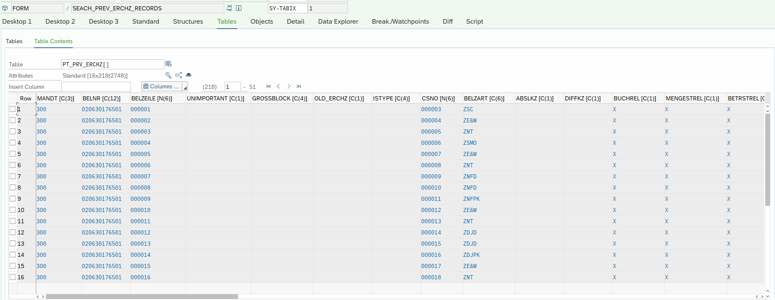
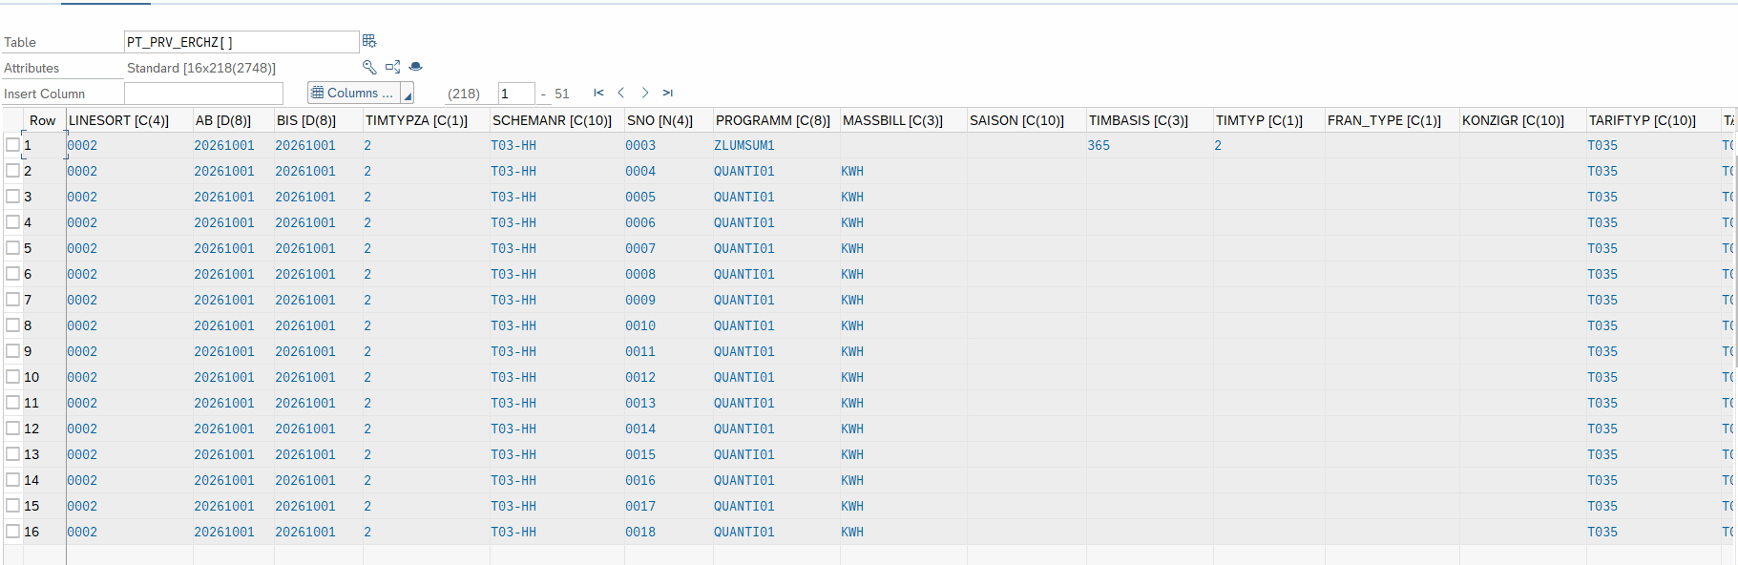
Below function returned as subrc = 4
FUNCTION ISU_DB_ERCHZ_SELECT_BILL.
*"----------------------------------------------------------------------
*"*"Lokale Schnittstelle:
*" IMPORTING
*" VALUE(X_BELNR) LIKE ERCH-BELNR
*" VALUE(X_BELZEILE) LIKE ERCHZ-BELZEILE OPTIONAL
*" VALUE(X_SORT) LIKE REGEN-KZ_SORT OPTIONAL
*" REFERENCE(X_ERCH) TYPE ERCH OPTIONAL
*" TABLES
*" T_ERCHZ STRUCTURE ERCHZ
*" EXCEPTIONS
*" NOT_FOUND
*" NOT_QUALIFIED
*" NOT_VALID
*"----------------------------------------------------------------------
DATA: ERCHZ_ZEILEN TYPE I,
DBT_ERCHZ TYPE ISU2A_DBBILL_DOC-IERCHZ,
WDBT_ERCHZ LIKE DBERCHZ,
WT_ERCHZ LIKE ERCHZ,
W_ERCHZ_N LIKE ERCHZ_N,
W_ERCHZ_D LIKE ERCHZ_D,
tab_erchz type erchz_tab.
DATA: lv_bill TYPE isu2a_bill_doc,
lv_buf_complete TYPE kennzx.
* Berechtigungsprüfungen und ähnliches
* ...
* Schlüssel muß mindestens aus Belegnummer bestehen
IF X_BELNR IS INITIAL.
* Interner Fehler: Fehlerhafter Parameter &2 (&3) im Fb &1
IF 1 = 2.
MESSAGE E896(E9) WITH 'ISU_DB_ERCHZ_SELECT_BILL'.
ENDIF.
MAC_MSG_PUTX CO_MSG_ERROR '896' 'E9'
'ISU_DB_ERCHZ_SELECT_BILL' SPACE SPACE SPACE NOT_QUALIFIED.
ENDIF.
* Before reading the data base look in the buffer
mac_prot_log_off.
CALL FUNCTION 'ISU_BUF_GET_BILL_SINGLE'
EXPORTING
x_belnr = x_belnr
x_sort = x_sort
x_read_erchz = 'X'
IMPORTING
y_bill = lv_bill
y_complete = lv_buf_complete
EXCEPTIONS
not_found = 1
system_error = 2
not_qualified = 3
OTHERS = 4.
mac_prot_log_on.
IF sy-subrc <> 0.
* MESSAGE ID SY-MSGID TYPE SY-MSGTY NUMBER SY-MSGNO
* WITH SY-MSGV1 SY-MSGV2 SY-MSGV3 SY-MSGV4.
ENDIF.
IF NOT lv_buf_complete IS INITIAL.
* we've everything we need.
t_erchz[] = lv_bill-ierchz[].
IF NOT x_belzeile IS INITIAL.
LOOP AT t_erchz.
IF t_erchz-belzeile <> x_belzeile.
DELETE t_erchz.
ENDIF.
ENDLOOP.
DESCRIBE TABLE t_erchz LINES erchz_zeilen.
IF erchz_zeilen = 0.
* Kein Eintrag zu Objekt &2 in Tabelle &1 gefunden
IF 1 = 2.
MESSAGE e183(ah) WITH 'ISU_DB_ERCHZ_SELECT_BILL'.
ENDIF.
mac_msg_putx co_msg_error '183' 'AH'
'ERCHZ' x_belnr space space not_found .
ENDIF.
ENDIF. "x_belzeile
EXIT.
ENDIF.
if x_erch-origdoc = co_ebf_migdoc.
* get the EBF-lines.
CALL FUNCTION 'ISU_DB_EBF_LINE_SELECT'
EXPORTING
x_erch = x_erch
IMPORTING
YT_ERCHZ = tab_erchz
EXCEPTIONS
NOT_FOUND = 1
NOT_QUALIFIED = 2
GENERAL_FAULT = 4
OTHERS = 5.
IF sy-subrc <> 0.
MAC_MSG_REPEAT CO_MSG_ERROR NOT_FOUND.
ENDIF.
loop at tab_erchz
into wt_erchz.
append wt_erchz to t_erchz.
endloop.
exit.
endif.
* sobald neue Strukturen aktiviert werden, die if-Abfrage raus!
* Suche in neuen DBERCHZ-Strukturen:
CALL FUNCTION 'ISU_DB_ERCHZ_SELECT_BILL_NEW'
EXPORTING
x_belnr = x_belnr
X_BELZEILE = x_belzeile
X_SORT = x_sort
tables
t_erchz = t_erchz
EXCEPTIONS
NOT_FOUND = 1
NOT_QUALIFIED = 2
NOT_VALID = 3
OTHERS = 4.
check sy-subrc <> 0.
* Wenn hier nichts gefunden, in der alten Struktur nachlesen
*endif.
* Alle Rechnungszeilen zum Beleg suchen
IF X_SORT = SPACE.
SELECT * FROM DBERCHZ INTO TABLE DBT_ERCHZ
WHERE BELNR = X_BELNR.
ELSE. " x_sort = space
SELECT * FROM DBERCHZ INTO TABLE DBT_ERCHZ
WHERE BELNR = X_BELNR
ORDER BY PRIMARY KEY.
ENDIF. " x_sort = space
IF SY-SUBRC <> 0.
IF 1 = 2.
MESSAGE E011(E9) WITH 'ISU_DB_ERCHZ_SELECT_BILL'.
ENDIF.
MAC_MSG_PUTX CO_MSG_ERROR '011' 'E9'
'ERCHZ' X_BELNR SPACE SPACE NOT_FOUND .
ENDIF.
* Übertragung der Daten in internes Format (wegen DEC-Feldern)
LOOP AT DBT_ERCHZ INTO WDBT_ERCHZ.
MOVE-CORRESPONDING WDBT_ERCHZ TO WT_ERCHZ.
MOVE-CORRESPONDING WDBT_ERCHZ TO W_ERCHZ_D.
CALL FUNCTION 'ISU_STRUCTURE_DBDATA_TRANSFORM'
EXPORTING
X_ERCHZ_D = W_ERCHZ_D
IMPORTING
Y_ERCHZ_N = W_ERCHZ_N
EXCEPTIONS
NOT_VALID = 1
OTHERS = 2.
IF SY-SUBRC = 0.
MOVE-CORRESPONDING W_ERCHZ_N TO WT_ERCHZ.
* Die Zeile muss als alte Zeile gekennzeichnet werden, falls sie
* anschliessend noch einmal upgedated werden soll:
wt_erchz-old_erchz = 'X'.
if wt_erchz-zeitant is initial.
wt_erchz-zeitant = wdbt_erchz-zeitant.
endif.
APPEND WT_ERCHZ TO T_ERCHZ.
ELSEIF SY-SUBRC = 1.
MAC_MSG_REPEAT CO_MSG_ERROR NOT_QUALIFIED.
ELSE.
MAC_MSG_PUTX_WP_WE CO_MSG_PROGRAMMING_ERROR 898 'E9' 'sy-subrc'
SY-SUBRC 'ISU_STRUCTURE_DBDATA_TRANSFORM' SPACE.
IF 1 = 2.
* nur wegen Verwendungsnachweis
MESSAGE A898(E9) WITH SPACE SPACE SPACE SPACE.
ENDIF.
ENDIF.
ENDLOOP.
* prepare writing the data to the buffer
lv_bill-ierchz[] = t_erchz[].
IF NOT X_BELZEILE IS INITIAL.
LOOP AT T_ERCHZ.
IF T_ERCHZ-BELZEILE <> X_BELZEILE.
DELETE T_ERCHZ.
ENDIF.
ENDLOOP.
DESCRIBE TABLE T_ERCHZ LINES ERCHZ_ZEILEN.
IF ERCHZ_ZEILEN = 0.
* Kein Eintrag zu Objekt &2 in Tabelle &1 gefunden
IF 1 = 2.
MESSAGE E183(AH) WITH 'ISU_DB_ERCHZ_SELECT_BILL'.
ENDIF.
MAC_MSG_PUTX CO_MSG_ERROR '183' 'AH'
'ERCHZ' X_BELNR SPACE SPACE NOT_FOUND .
ENDIF.
ENDIF. "x_belzeile
* store the data in the buffer
CALL FUNCTION 'ISU_BUF_SET_BILL_SINGLE'
EXPORTING
x_belnr = x_belnr
x_bill = lv_bill
x_read_erchz = 'X'.
ENDFUNCTION. " isu_db_erchz_select_bill
Maybe 21 read reason is required?
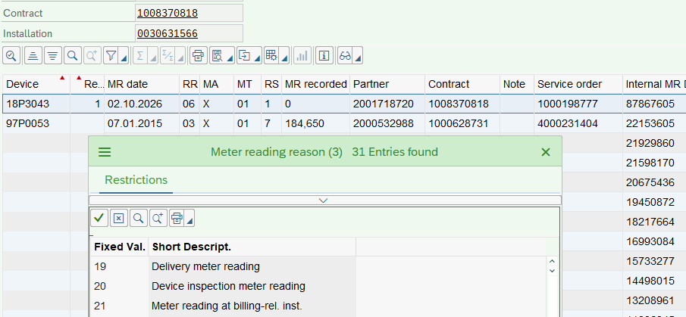

5)
332MM will contain meter install information for the newly installed Non-interval meter.

